**Project Design**

**1. Introduction**

**Number of Modules**

There are 11 major modules involved in the project. Consider the figure below.

Products Submission by Seller

Register as a seller or Buyer

Login Module

Product Buying Module

Post Product Requirements

Content based recommendations

Collaboration Based recommendations

Review collection and polarity computation

Hybrid Based Recommendations

Price recommendation

Association Rule Mining

*Fig. Modules of the project*

**Modules Description**

1. Register as Seller or Buyer:This module is responsible for any user to register in the application by entering the personal details like Username, Password, Email, Phone No, Type (Buyer and Seller).
2. Login Module: This module is responsible for any user to perform login into the application.
3. Product Submission by Seller: This Module is responsible for submitting of the products by giving details like Product Name, Product Description, Product Cost, Category (Mobile, Book, Tablet, Laptop, and Electronics)
4. Product Buying Module: This Module is responsible for purchase of products by selecting the product and entering the payment detail.
5. Content Based Recommendations: This Module analyzes the transaction history of the buyers through the transaction logs. A user customized threshold is set. If any of the products exceeds the specific threshold then recommendations of the product are suggested.

Profile of User

Transaction Logs

Threshold Settings

Recommendation Engine

*Fig: Content Based Recommendation*

1. Figure shows that the profile of the user and his/her threshold settings along with transaction logs acts as an input for recommendations engine and recommendation engine filters the transaction based on threshold criteria.
2. Collaborative Based Recommendation: This Module is responsible for gaining the rating across the registered as well as unregistered users. The recommendations are generated based on the aggregated rating across the users of the application.
3. Association Rule Mining: This Module is responsible for doing the intersection between the content based recommendations and collaborative based recommendations.
4. Review based recommendation(Hybrid): This Module is responsible for collecting the reviews for the products, cleaning of the reviews, the amount of positive polarity, negative polarity and neutral polarity and recommend products which are ranked based on maximum positive polarity, neutral polarity and lowest negative polarity.

Collection of Reviews

Cleaning of Reviews

Positive Polarity

Negative Polarity

Neutral Polarity

Recommendations Engine

*Fig: Review Based Recommendations*

1. Collection of Reviews – This Module is responsible for collecting the reviews from the registered users. This module will collect reviews based on actions that are required on the products.
2. Cleaning of Reviews- This Module is responsible for cleaning of each of the reviews by removing unused or unwanted words.
3. Positive Polarity Computation - This is a process in which each of the reviews are separated by a delimiter. Each of the statements in the all the reviews are then compared against the positive thoughts or positive keywords listed by the data mining forums.
4. Negative Polarity Computation - This is a process in which each of the reviews are separated by a delimiter. Each of the statements in the all the reviews are then compared against the negative thoughts or negative keywords listed by the data mining forums.
5. Neutral Polarity Computation - This is a process in which each of the reviews are separated by a delimiter. Each of the statements in the review list is assigned a neutral review if the positive and negative reviews both are empty.
6. Recommendation Engine - This Module is responsible for ranking of products based on maximum positive polarity, less negative polarity and more neutral polarity
7. Price Recommendation: This module is responsible for recommending price for a product that seller wishes to sell considering the attribute values provided by the user and a data set of similar products.

**Algorithm design**

1. Algorithm for Login Module

Login Page

Customer/admin enters the username and password

Validate the username and password

Navigate to home page to view products.

Valid?

YES

No

1. Algorithm for User Registration

User Register Page

Customer enter s the username, password, email

Validate the username and password and other fields

User Information is stored in database

1. Algorithm for Product Buying Module

The customer logs in with username and password

Login successful

View List of Products

Click on Product to Buy

The customer enters the account no and pin

If the account no and PIN is valid succeed

Update the Balance appropriately and complete the transaction

Valid?

No

Yes

1. Algorithm for Content Based Recommendation

Retrieve product selected from product list and user’s Personal Settings

Find the List of products under the transactions performed by the user

If the count of transactions on the product exceeds the personal settings then it comes under content based recommendation list

1. Algorithm for Collaborative based Recommendation

Retrieve Rating and List of Products

Find the List of Products whose rating is minimum 4

Rank the products based on descending order of the direct rating

Add the products to collaborative recommendation list

1. Algorithm for Association Rule Mining

Obtain the List of content based Products

Obtain the List of Collaborative based Products

Perform the intersection between content and collaborative

Add the result to Association rule mining list

1. Algorithm for Hybrid Recommendation

Retrive a List of Reviews (Nreviews)



i=1

Divide the ith review into set of statements

Check whether the statement contains the positive keywords and increment positive polarity

Check whether the statement contains the negative keywords and increment negative polarity

If Statement does not contain any positive keyword or negative keyword then neutral rating=1

i=i+1

YES

Compute Total Polarity

Rank Products

No

1. Algorithm for Price Recommendation

Obtain the product attributes from user

Obtain sample data set with various attribute values and price class for similar products

Apply Naïve Bayes algorithm to predict the class for user product

Recommend the product price to the user

**2. Architecture Design**

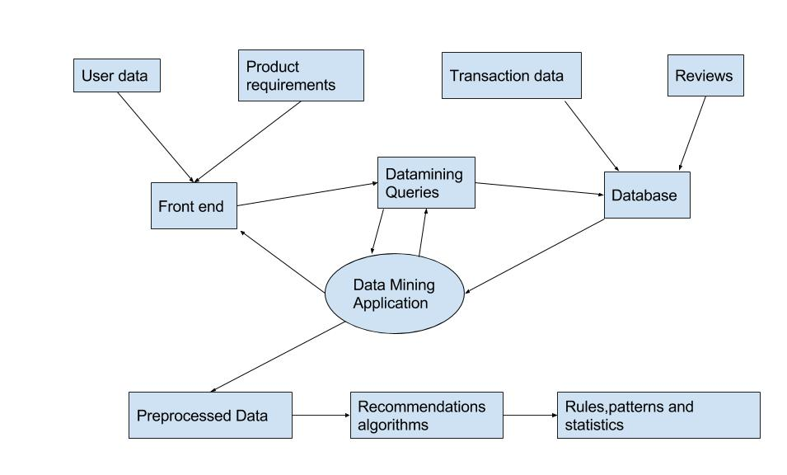

**3. Graphical User Interface**

Register:

* Fields are: Username, type=”text”

Password, type=”password”

Email, type=”email”

Phone no.,type=”number”

* This page calls the register() function

Login:

* Fields are: UserID, type=”text”

Password, type=”password”

* This form calls login(), which will verify the details entered.

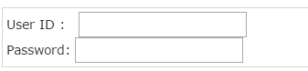

Uploading the product:

* Fields are : Upload image , name=”fileupload” type=”file” accept=”image/*”

Add product description, name=”description” rows=”5” cols=”50”

Submit button, type=”submit” name=”submit” value=”submit”

* Once this form is submitted, the values are added to the database.



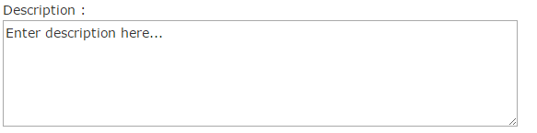



Direct rating:

* This form enables the user to rate a particular product.
* It contains a dropdown box containing numbers from 1 to 5, where 1 is the lowest rating and 5 is the highest rating.
* Fields are: name=”dropdown”

value=”1”

value=”2”

value=”3”

value=”4”

value=”5”

Submit button, type=”submit” name=”submit” value=”submit”

* After this form has been submitted, getDirectRating() is called, which saves the rating of that particular product.

Hybrid Recommendation:

* This calls the getReviews(), getReviewPolarity() functions.
* Product recommendations are seen on the page.

Association Rule Mining:

* Calls getContentBasedList(), getCollaborativeList() and associationRuleMining() functions
* Product recommendations are seen on the page

Content Based Recommendation:

It will call content based recommendation function and personal settings function and checks transaction logs internally and recommendation engine finally shows products in this category.

Collaborative based Recommendation:

It shows recommendation based on the rating of the product.

**4. Class Diagram**

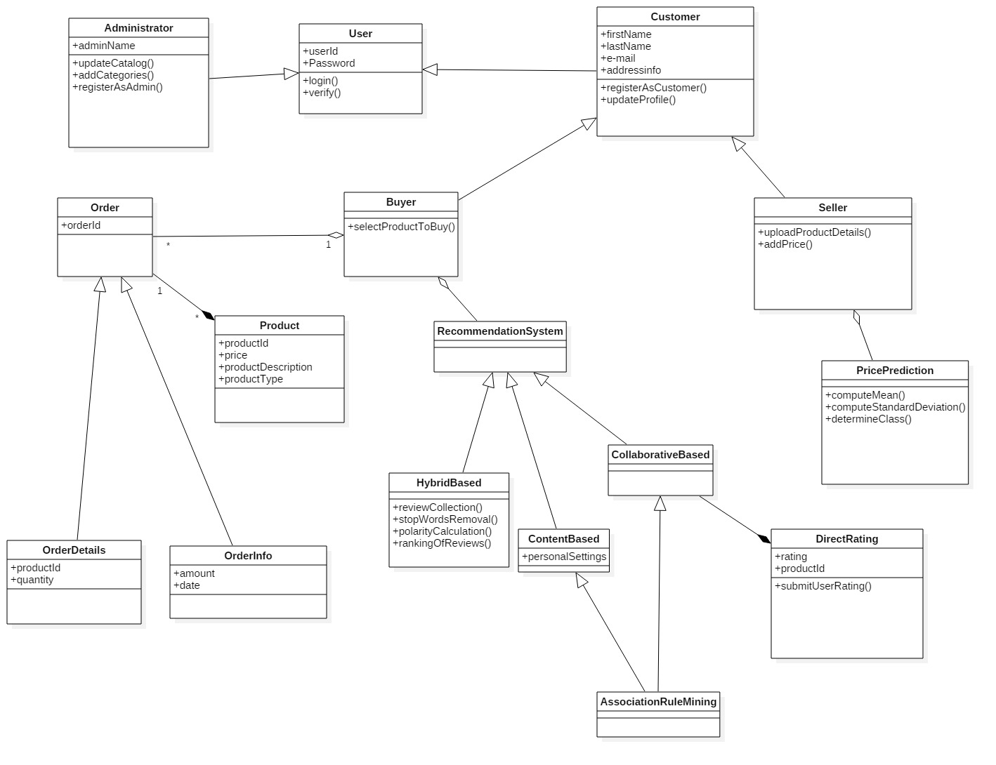

**5. Sequence Diagram**

1. Registration

C:\Users\LAKSHMI\Downloads\register module.png

b) Login

C:\Users\LAKSHMI\Downloads\Untitled Diagram.png

1. Product Submission by Seller

C:\Users\LAKSHMI\Downloads\Untitled Diagram (1).png

1. Product Buying

C:\Users\LAKSHMI\Downloads\Untitled Diagram (2).png

1. Content based recommendation

C:\Users\LAKSHMI\Downloads\Untitled Diagram (3).png

1. Collaborative based recommendation

C:\Users\LAKSHMI\Downloads\collaboration based seq diag.png

1. Association Rule Mining

C:\Users\LAKSHMI\Downloads\association rule mining seq diag.png

1. Hybrid Recommendation

C:\Users\LAKSHMI\Downloads\Hybrid seq diag.png

1. Price recommendation

C:\Users\LAKSHMI\Downloads\Price recommendation seq diag.png

**6**. **Data flow diagram**

User Information, Transaction History, Direct Rating

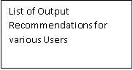

Fig shows the DFD with the inputs namely User Information, Transaction History, Direct Ratings and Reviews. The processes are List of products in the transaction history, product rating, Content Based Algorithm, Collaborative Based Recommendations, and Association Rule Mining, Review Collection, Data Cleaning, Polarity Computation & Hybrid Recommendations. The output is list of 4 types of recommendations namely Content Based Recommendations, Collaborative Recommendations, Association Rule Mining and Hybrid Recommendations.

**7. References**

1. Online UML software tool - <https://www.draw.io/>
2. UML tool- StarUML
3. <http://study.com/academy/lesson/consumer-to-consumer-c2c-e-commerce-definition-business-model-examples.html>
4. The article “*Study on web mining and electronic commerce”*, by Mingshu Ren, of Shandong University of Science and Technology, Shandong